Burette
# Source: AI Source: Provided by: [Data Path: Persons Table -> ID Column: 1, Name_En Column: Motasem Essam] -> From: [ChatGPT] on [7/17/2026]
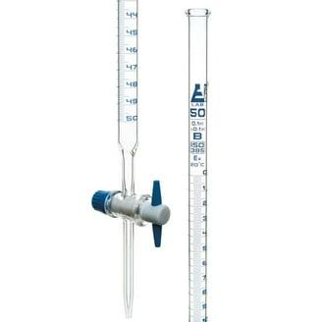
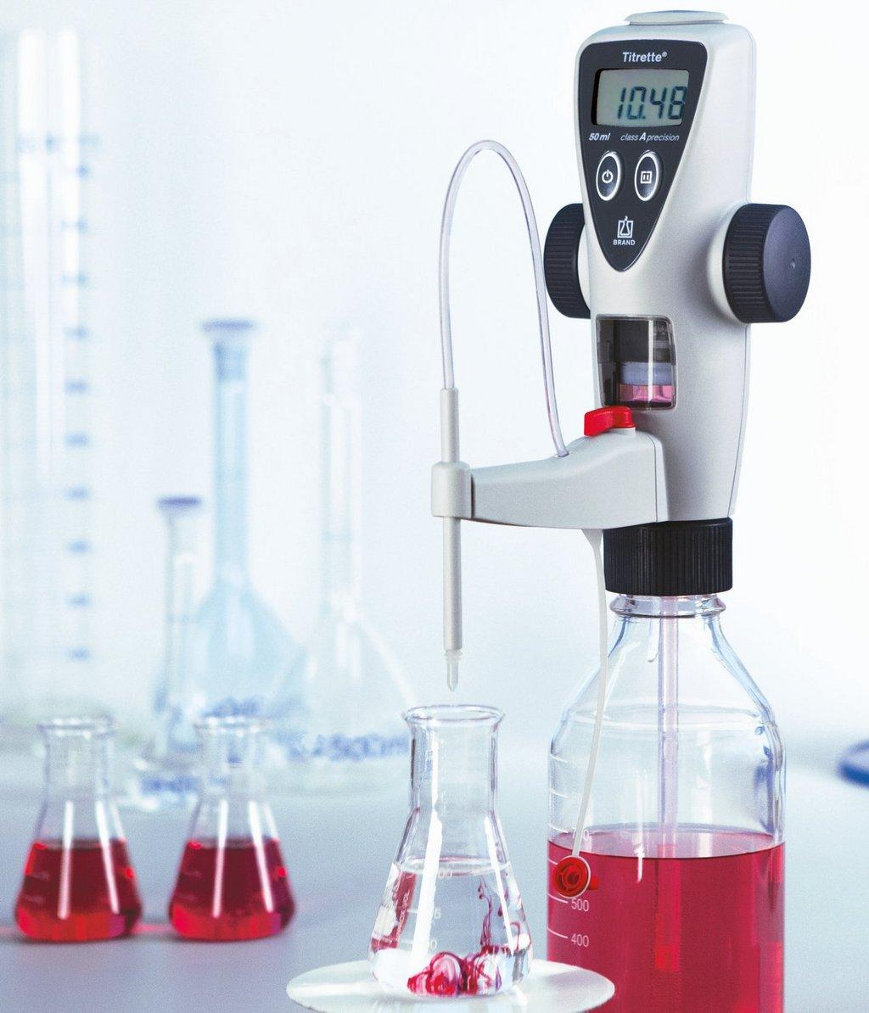
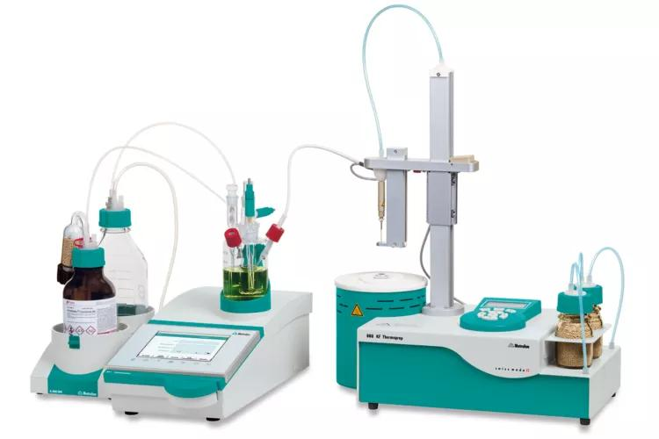
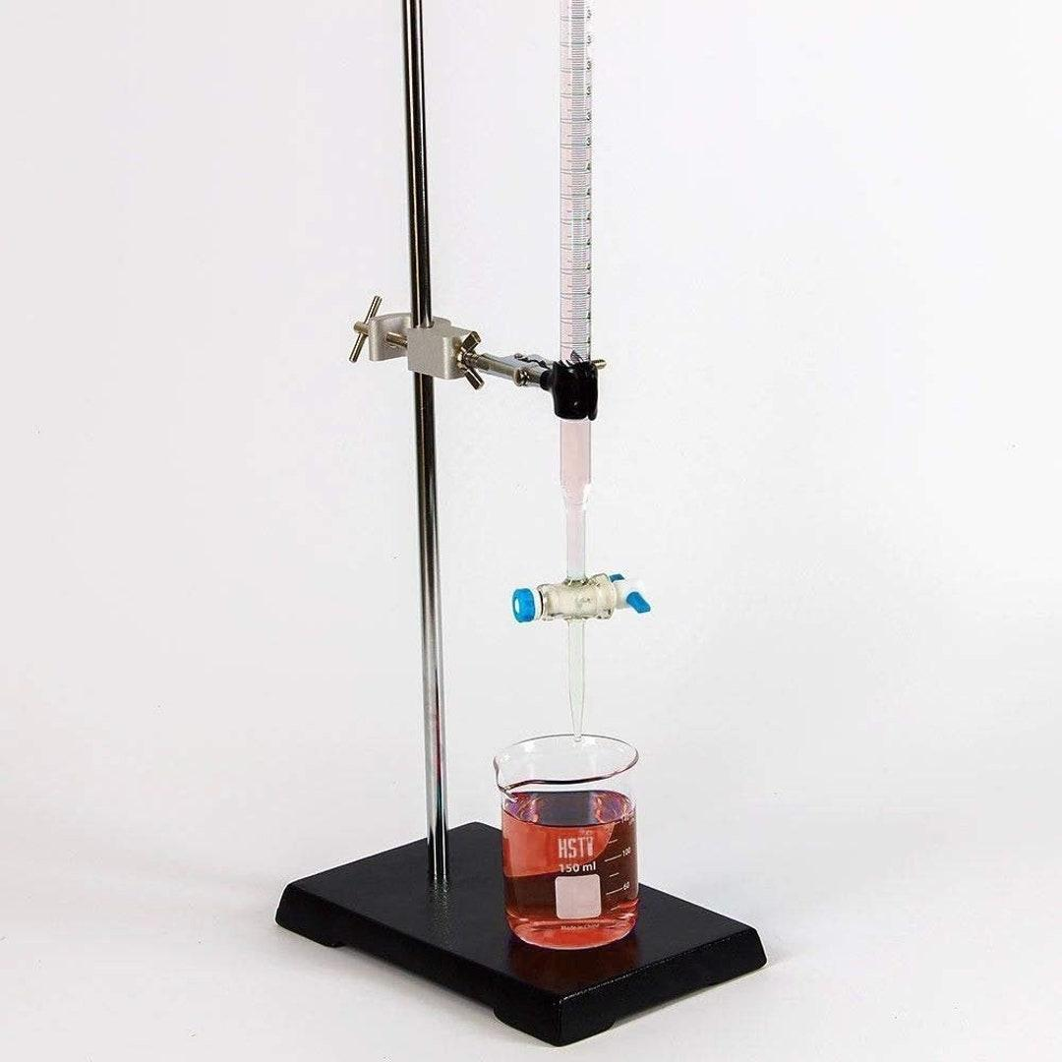
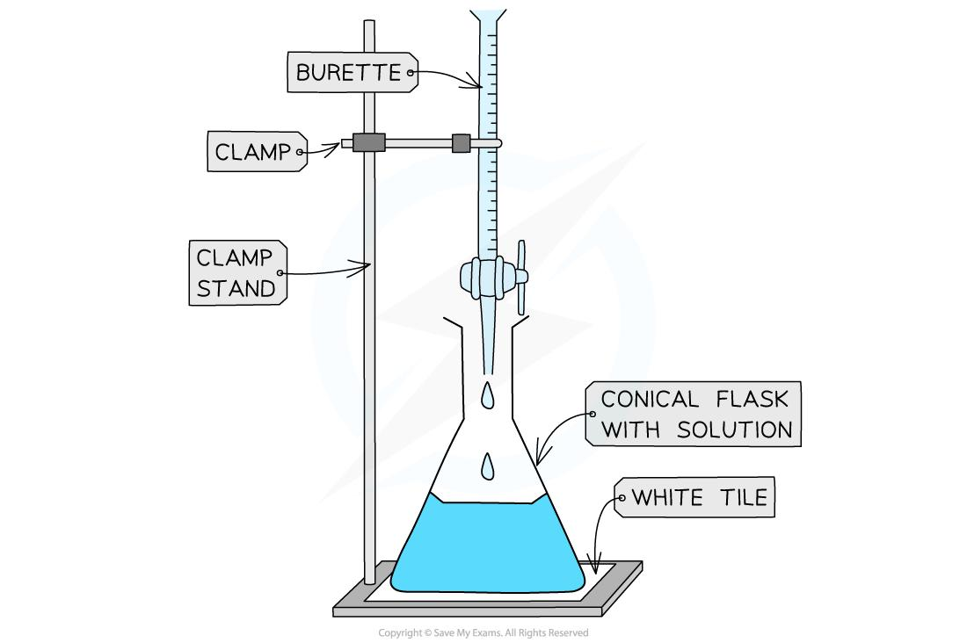
A Burette (also spelled Buret) is a precision laboratory volume-measuring instrument designed to accurately dispense controlled volumes of liquid, one drop at a time. It is primarily used in volumetric analysis, especially acid-base titrations, where highly accurate measurement of the delivered liquid volume is required.
The burette is one of the most accurate instruments for dispensing variable liquid volumes in analytical chemistry.

Definition
# Source: AI Source: Provided by: [Data Path: Persons Table -> ID Column: 1, Name_En Column: Motasem Essam] -> From: [ChatGPT] on [7/17/2026]
A Burette is a graduated glass or digital laboratory instrument equipped with a stopcock that accurately measures and dispenses variable volumes of liquid.

Purpose
# Source: AI Source: Provided by: [Data Path: Persons Table -> ID Column: 1, Name_En Column: Motasem Essam] -> From: [ChatGPT] on [7/17/2026]
A burette is used to:
- Deliver precise liquid volumes.
- Perform titrations.
- Measure unknown concentrations.
- Prepare analytical solutions.
- Control reagent addition drop by drop.
- Conduct quantitative chemical analysis.

Principle of Operation
# Source: AI Source: Provided by: [Data Path: Persons Table -> ID Column: 1, Name_En Column: Motasem Essam] -> From: [ChatGPT] on [7/17/2026]
Principle of Operation
A burette works by gravity.
The liquid flows downward through a stopcock at the bottom of the burette. The user controls the flow rate by opening or closing the stopcock.
The delivered volume is determined by subtracting:
$$\text{Delivered Volume}=\text{Final Reading}-\text{Initial Reading}$$
Unlike most measuring instruments, the burette scale increases downward because it measures the volume dispensed, not the volume remaining.

Main Components
# Source: AI Source: Provided by: [Data Path: Persons Table -> ID Column: 1, Name_En Column: Motasem Essam] -> From: [ChatGPT] on [7/17/2026]
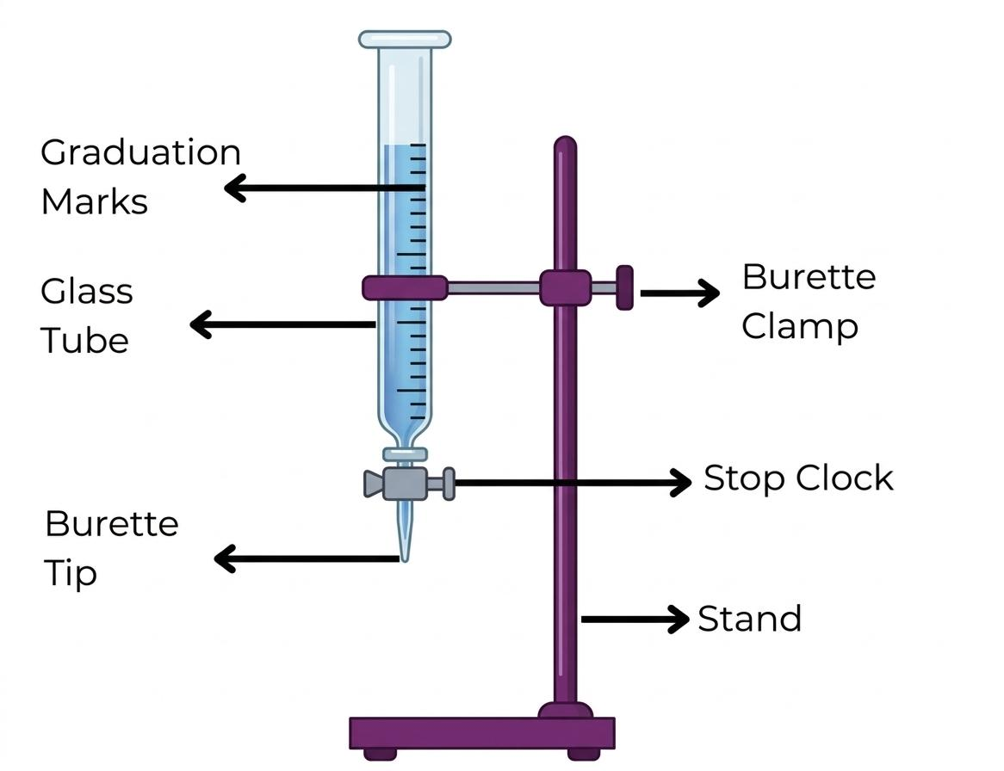
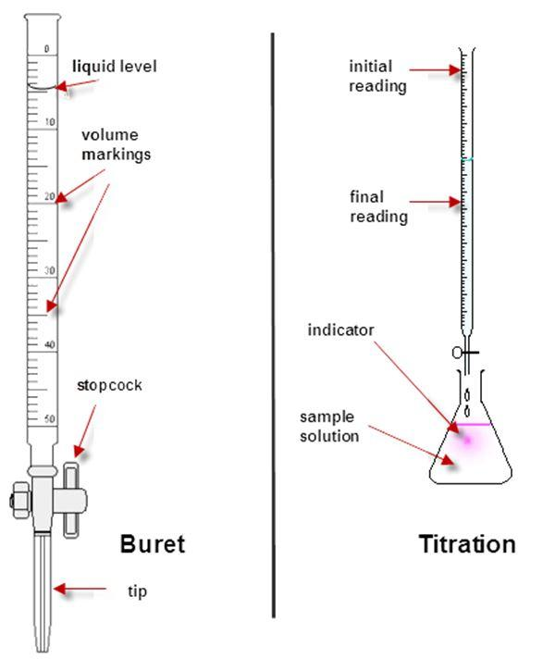
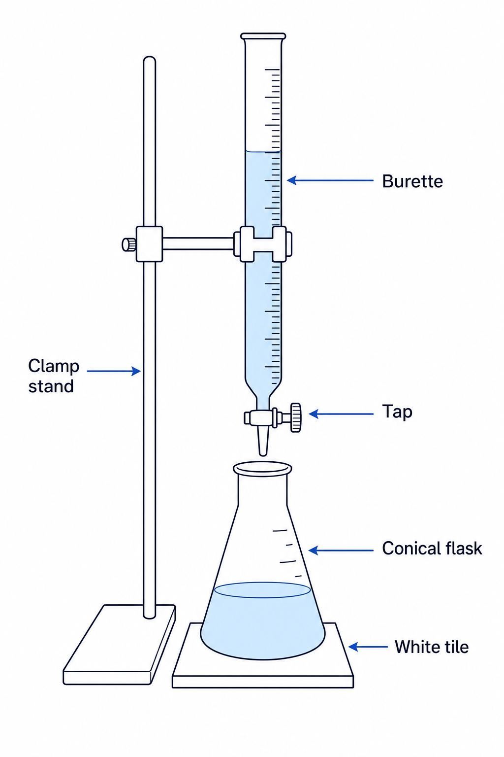
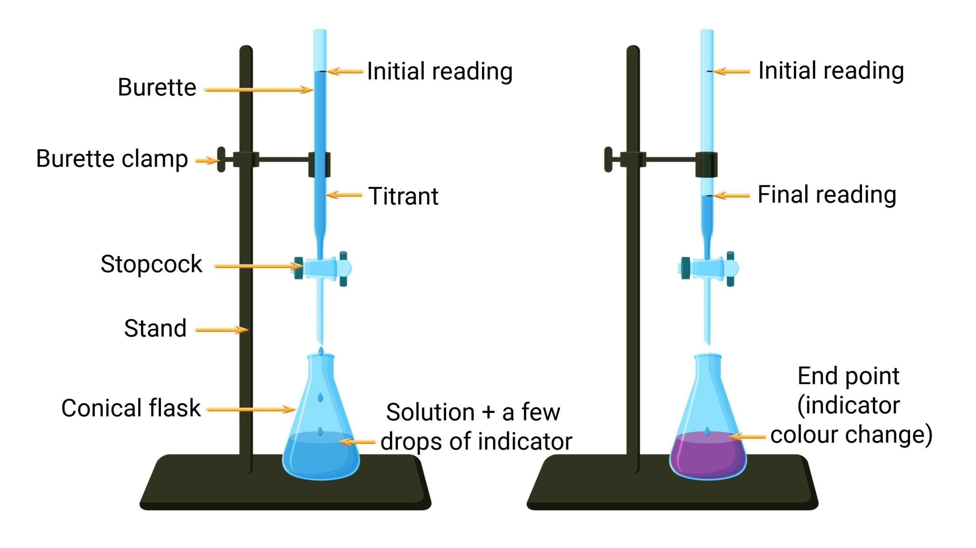
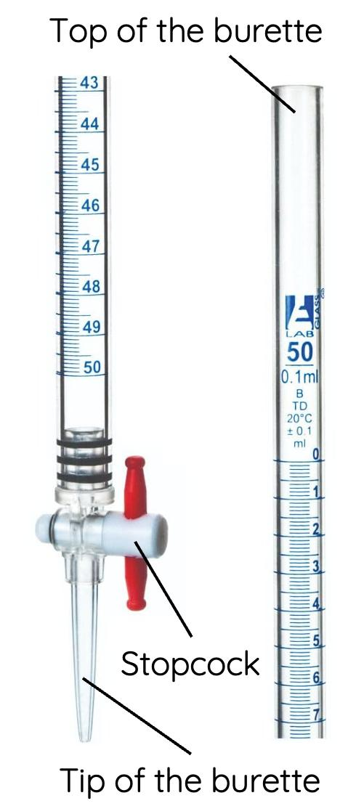
A typical burette consists of:
- Graduated glass tube
- Graduation scale
- Stopcock (tap or valve)
- Delivery tip
- Upper filling opening
- Clamp attachment area

Types of Burettes

1. Glass Burette
# Source: AI Source: Provided by: [Data Path: Persons Table -> ID Column: 1, Name_En Column: Motasem Essam] -> From: [ChatGPT] on [7/17/2026]
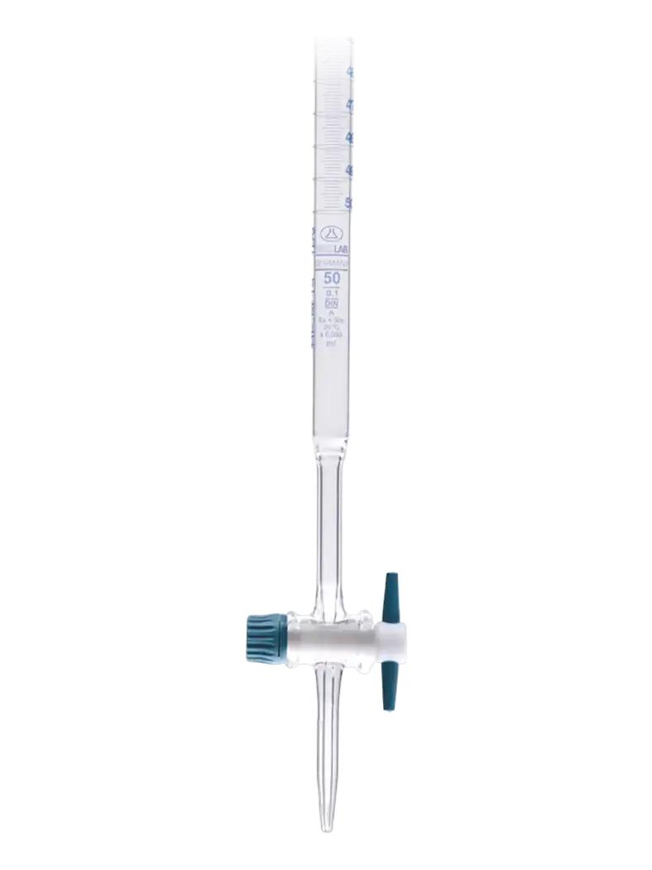
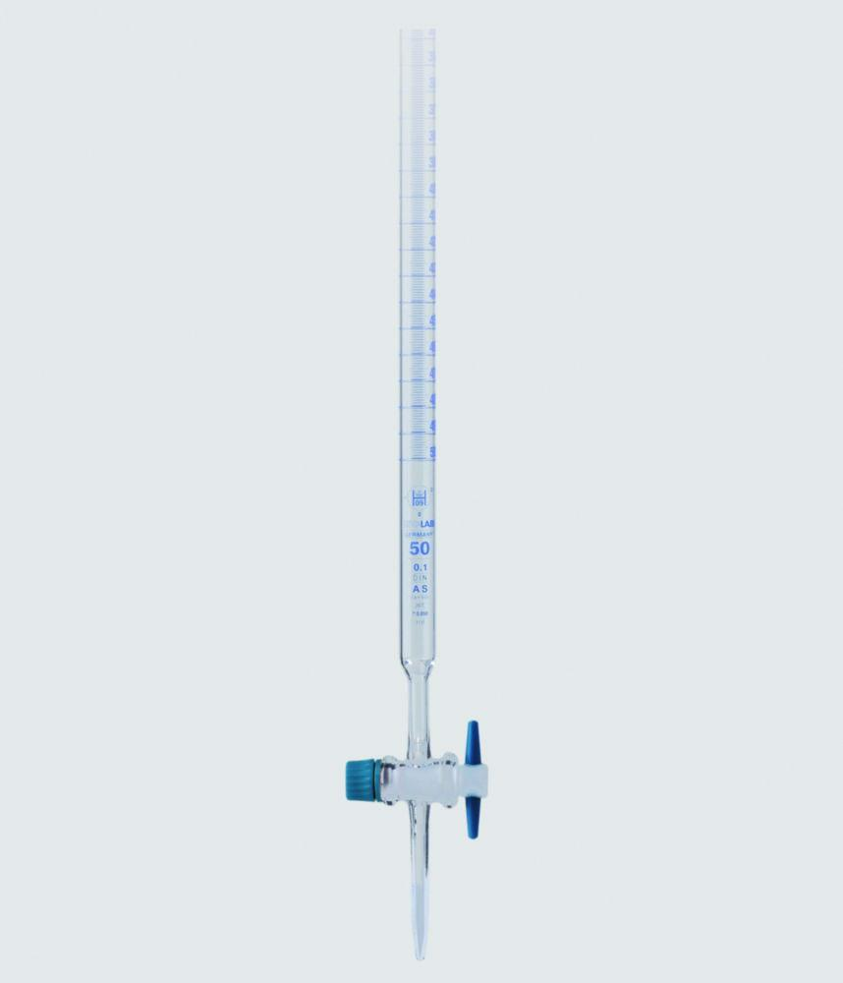
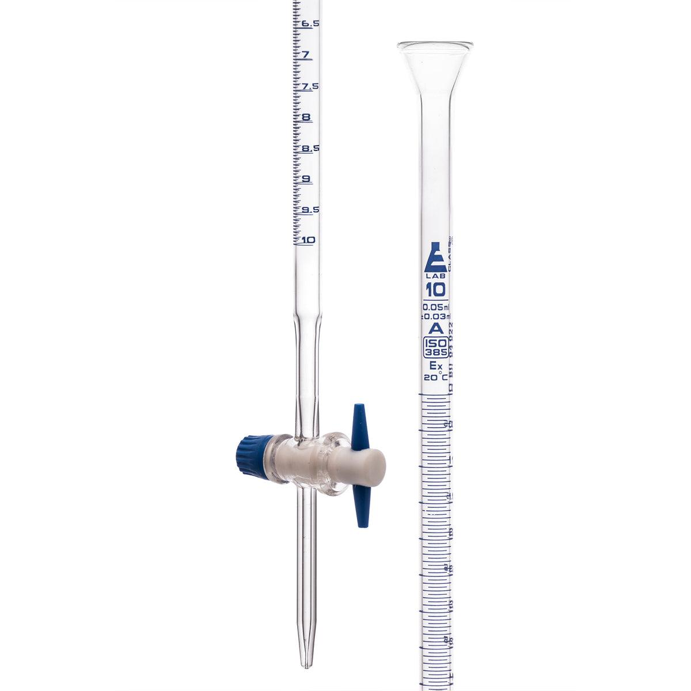
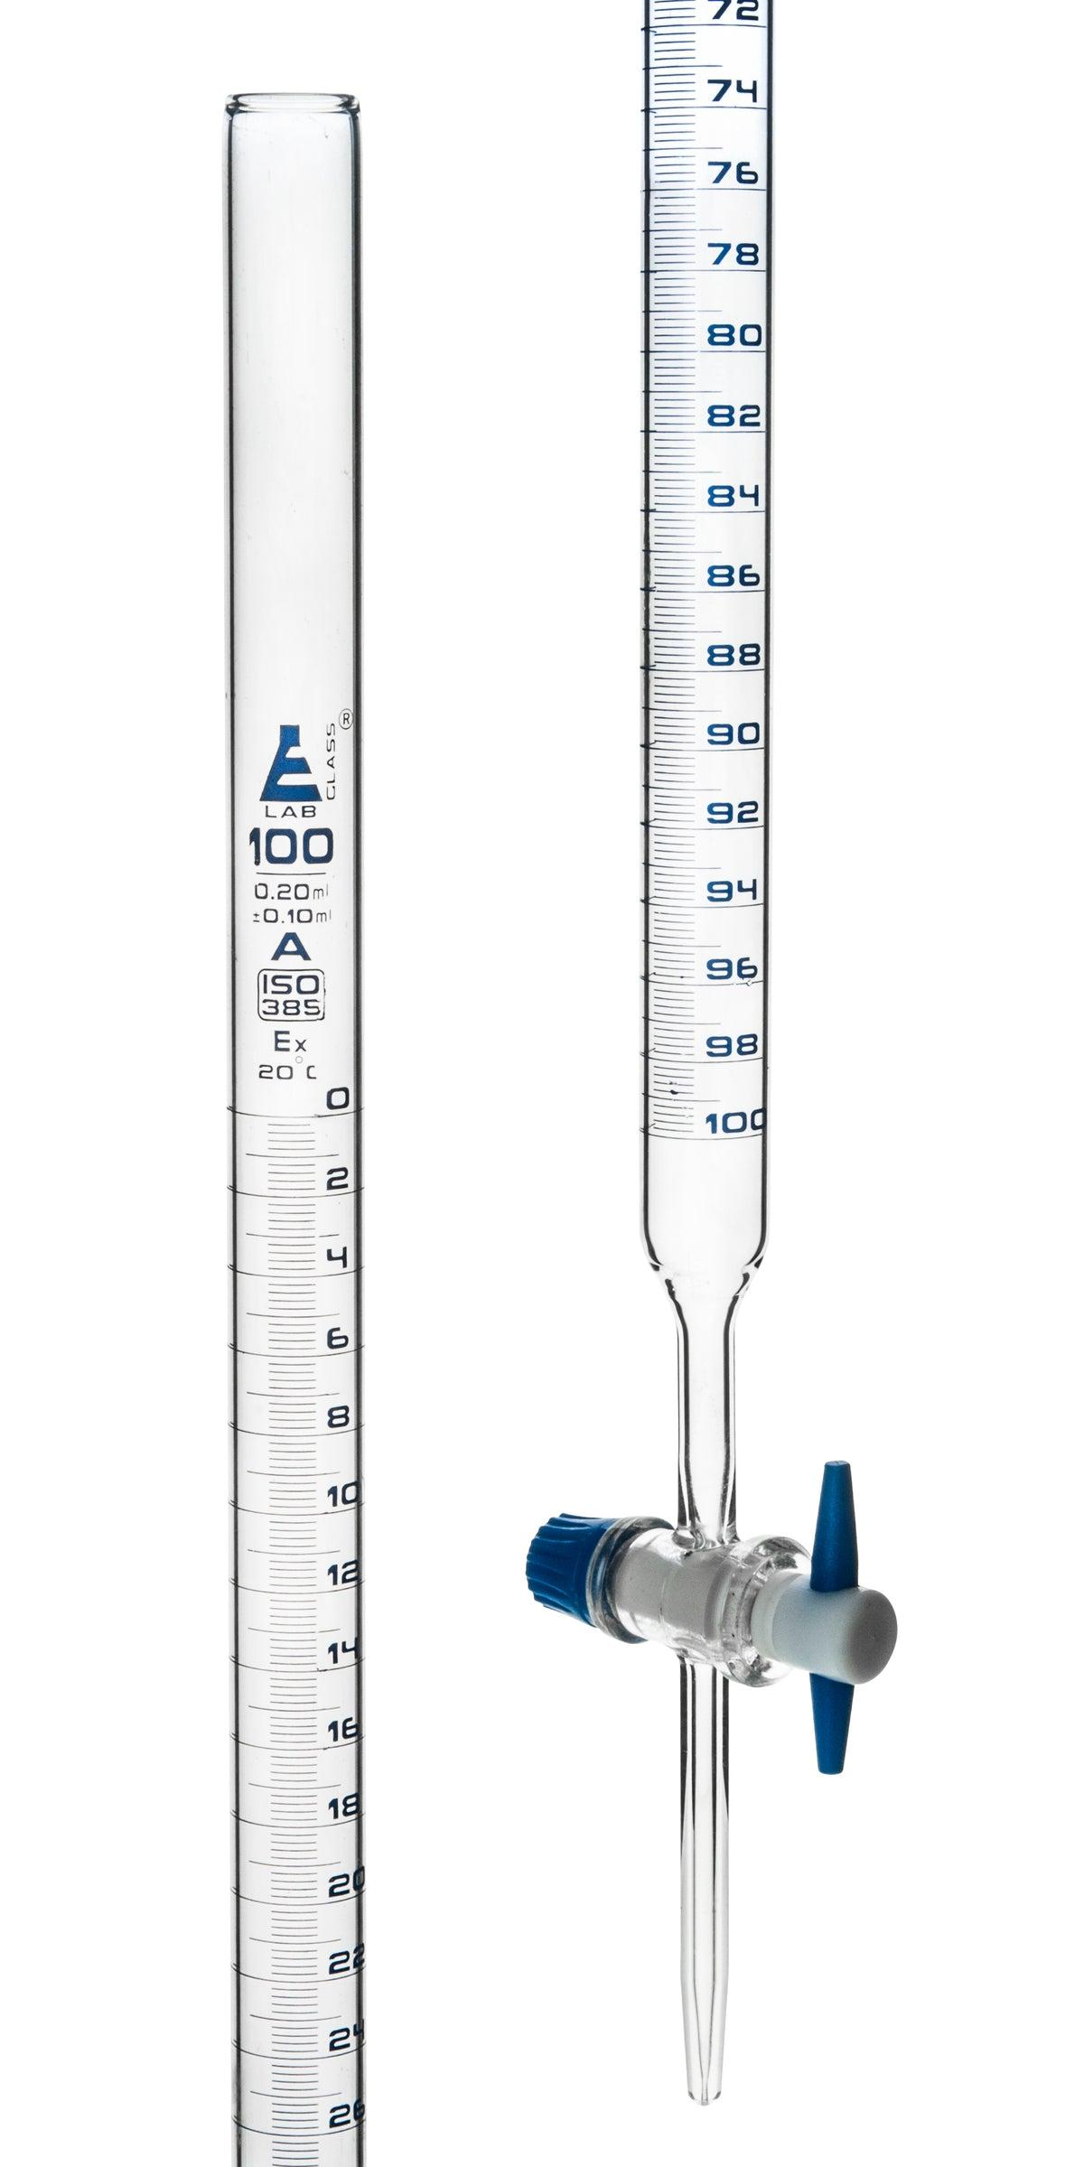
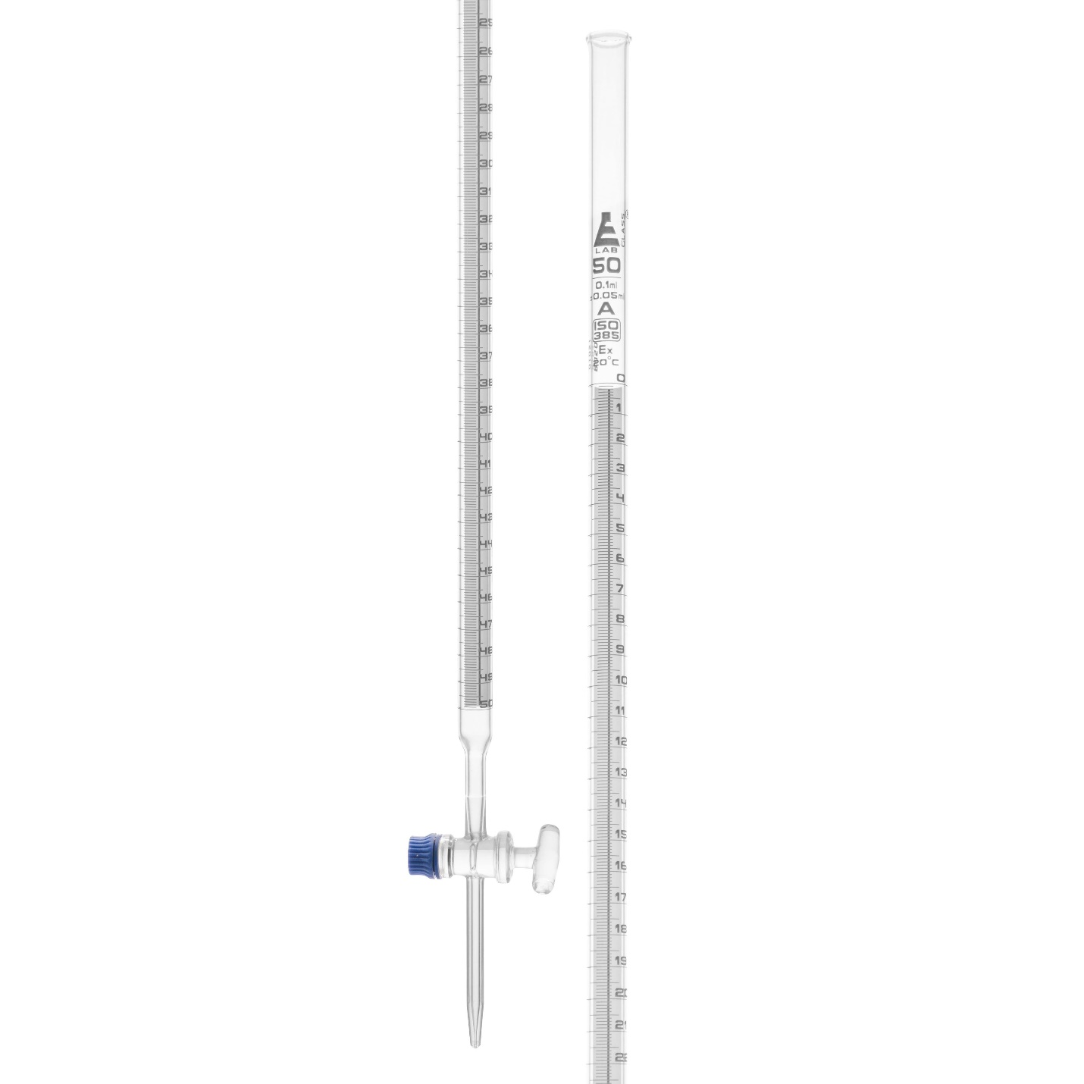
Description
The traditional laboratory burette made from borosilicate glass.
Features
- High accuracy
- Transparent
- Chemically resistant
Applications
- Analytical chemistry
- Academic laboratories
- Pharmaceutical laboratories

2. Digital Burette
# Source: AI Source: Provided by: [Data Path: Persons Table -> ID Column: 1, Name_En Column: Motasem Essam] -> From: [ChatGPT] on [7/17/2026]
Description
An electronically controlled burette with digital volume display.
Features
- Digital readout
- Reduced reading errors
- Improved repeatability
Applications
- High-precision laboratories
- Industrial analysis

3. Automatic Burette
# Source: AI Source: Provided by: [Data Path: Persons Table -> ID Column: 1, Name_En Column: Motasem Essam] -> From: [ChatGPT] on [7/17/2026]
Description
Connected directly to reagent bottles for repeated dispensing.
Applications
- Routine laboratory analysis
- Quality control
- Pharmaceutical production

Measuring Units
# Source: AI Source: Provided by: [Data Path: Persons Table -> ID Column: 1, Name_En Column: Motasem Essam] -> From: [ChatGPT] on [7/17/2026]
Burettes measure:
- Milliliters (mL)
Typical graduations:
- 0.1 mL
- 0.05 mL
- 0.02 mL

Common Capacities
# Source: AI Source: Provided by: [Data Path: Persons Table -> ID Column: 1, Name_En Column: Motasem Essam] -> From: [ChatGPT] on [7/17/2026]
Typical burette capacities:

Capacity
10 mL
25 mL
50 mL
100 mL
The 50 mL burette is the most commonly used.

Resolution
# Source: AI Source: Provided by: [Data Path: Persons Table -> ID Column: 1, Name_En Column: Motasem Essam] -> From: [ChatGPT] on [7/17/2026]
Typical resolution:
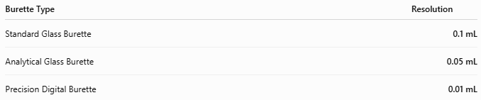
Burette Type | Resolution
Standard Glass Burette | 0.1 mL
Analytical Glass Burette | 0.05 mL
Precision Digital Burette | 0.01 mL

Accuracy
# Source: AI Source: Provided by: [Data Path: Persons Table -> ID Column: 1, Name_En Column: Motasem Essam] -> From: [ChatGPT] on [7/17/2026]
Typical accuracy:
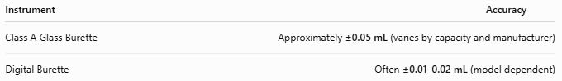
Instrument | Accuracy
Class A Glass Burette | Approximately ±0.05 mL (varies by capacity and manufacturer)
Digital Burette | Often ±0.01–0.02 mL (model dependent)

Measuring Range
# Source: AI Source: Provided by: [Data Path: Persons Table -> ID Column: 1, Name_En Column: Motasem Essam] -> From: [ChatGPT] on [7/17/2026]
Typical measuring range:
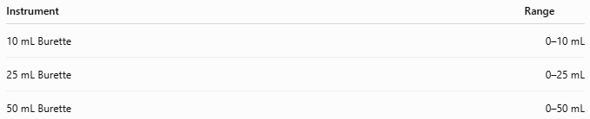
Instrument | Range
10 mL Burette | 0–10 mL
25 mL Burette | 0–25 mL
50 mL Burette | 0–50 mL

Reading a Burette
# Source: AI Source: Provided by: [Data Path: Persons Table -> ID Column: 1, Name_En Column: Motasem Essam] -> From: [ChatGPT] on [7/17/2026]
- Fill the burette.
- Remove any air bubbles from the tip.
- Record the initial reading.
- Dispense the liquid.
- Record the final reading.
- Calculate:
$$\text{Delivered Volume}=\text{Final Reading}-\text{Initial Reading}$$
Read the bottom of the meniscus at eye level.

Example
# Source: AI Source: Provided by: [Data Path: Persons Table -> ID Column: 1, Name_En Column: Motasem Essam] -> From: [ChatGPT] on [7/17/2026]
Initial reading:
2.30 mL
Final reading:
18.75 mL
Delivered volume:
$$18.75-2.30=16.45\text{ mL}$$

Applications
# Source: AI Source: Provided by: [Data Path: Persons Table -> ID Column: 1, Name_En Column: Motasem Essam] -> From: [ChatGPT] on [7/17/2026]
Burettes are used in:
- Acid-base titrations
- Redox titrations
- Complexometric titrations
- Precipitation titrations
- Pharmaceutical analysis
- Food analysis
- Water quality testing
- Chemical research
- University laboratories

Sources of Error
# Source: AI Source: Provided by: [Data Path: Persons Table -> ID Column: 1, Name_En Column: Motasem Essam] -> From: [ChatGPT] on [7/17/2026]
Instrument Errors
- Calibration error
- Worn stopcock
- Leaking valve
- Damaged graduations

User Errors
- Parallax error
- Reading the wrong meniscus
- Forgetting the initial reading
- Air bubbles in the tip
- Dispensing too quickly

Environmental Errors
- Temperature changes affecting liquid volume
- Evaporation of volatile reagents
- Vibrations

Advantages
# Source: AI Source: Provided by: [Data Path: Persons Table -> ID Column: 1, Name_En Column: Motasem Essam] -> From: [ChatGPT] on [7/17/2026]
A burette:
- Provides very high accuracy.
- Dispenses variable liquid volumes.
- Allows controlled dropwise addition.
- Is ideal for titration work.
- Has excellent repeatability.

Limitations
# Source: AI Source: Provided by: [Data Path: Persons Table -> ID Column: 1, Name_En Column: Motasem Essam] -> From: [ChatGPT] on [7/17/2026]
A burette:
- Is fragile (glass models).
- Requires careful cleaning.
- Must be clamped vertically.
- Needs calibration for precise work.
- Reading errors are possible if the meniscus is viewed incorrectly.

Comparison with Other Volume Measuring Instruments
# Source: AI Source: Provided by: [Data Path: Persons Table -> ID Column: 1, Name_En Column: Motasem Essam] -> From: [ChatGPT] on [7/17/2026]
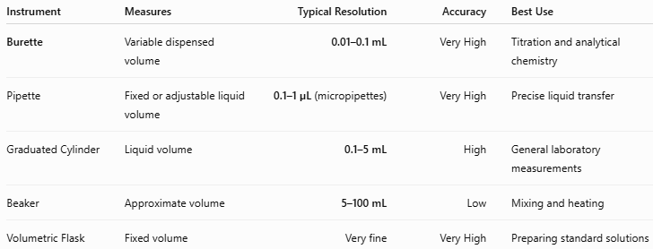
Instrument | Measures | Typical Resolution | Accuracy | Best Use
Burette | Variable dispensed volume | 0.01–0.1 mL | Very High | Titration and analytical chemistry
Pipette | Fixed or adjustable liquid volume | 0.1–1 µL (micropipettes) | Very High | Precise liquid transfer
Graduated Cylinder | Liquid volume | 0.1–5 mL | High | General laboratory measurements
Beaker | Approximate volume | 5–100 mL | Low | Mixing and heating
Volumetric Flask | Fixed volume | Very fine | Very High | Preparing standard solutions

Care and Maintenance
# Source: AI Source: Provided by: [Data Path: Persons Table -> ID Column: 1, Name_En Column: Motasem Essam] -> From: [ChatGPT] on [7/17/2026]
To maintain accuracy:
- Rinse with distilled water after use.
- Store vertically when clean.
- Inspect for cracks and leaks.
- Lubricate glass stopcocks when appropriate.
- Remove air bubbles before measurements.
- Calibrate periodically in analytical laboratories.

Common Mistakes
# Source: AI Source: Provided by: [Data Path: Persons Table -> ID Column: 1, Name_En Column: Motasem Essam] -> From: [ChatGPT] on [7/17/2026]
- Reading the scale from the top instead of the bottom of the meniscus.
- Forgetting that the burette scale increases downward.
- Leaving air bubbles in the delivery tip.
- Allowing leaks through an improperly closed stopcock.
- Recording only the final reading instead of calculating the delivered volume.

Key Points
# Source: AI Source: Provided by: [Data Path: Persons Table -> ID Column: 1, Name_En Column: Motasem Essam] -> From: [ChatGPT] on [7/17/2026]
- A Burette is a precision volume-dispensing instrument.
- It is primarily used for:
  - Acid-base titrations
  - Volumetric analysis
  - Analytical chemistry
- Common types:
  - Glass Burette
  - Digital Burette
  - Automatic Burette
- Typical capacities:
  - 10, 25, 50, and 100 mL
- It measures the volume delivered, so its graduation scale increases from top to bottom.
- It is one of the most accurate instruments for dispensing variable liquid volumes.

Conclusion
# Source: AI Source: Provided by: [Data Path: Persons Table -> ID Column: 1, Name_En Column: Motasem Essam] -> From: [ChatGPT] on [7/17/2026]
A Burette is an essential laboratory instrument for high-precision dispensing of liquids, especially in volumetric analysis and titration experiments. Its finely graduated scale, controlled stopcock, and ability to accurately deliver variable volumes make it indispensable in analytical chemistry, pharmaceuticals, environmental testing, and research laboratories. When properly calibrated and used with correct meniscus-reading techniques, the burette provides the precision required for quantitative chemical analysis.

